Assignment-2 EEC-3150 Engineering Programming II
- In the Blackboard Resources is a LinkedIn Learning course entitled Python Essential Training.

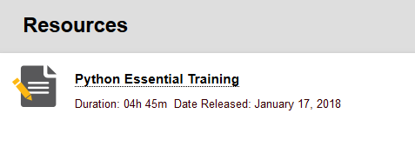
Review any lessons from the following chapters to increase your understanding:
Chapter 3. Types and Values
Chapter 4. Conditionals
Chapter 5. Operators
Chapter 6. Loops

You may choose any of the videos, or all of the videos that will increase your knowledge of the Python programming language. You are to enumerate five learnings from the videos you have selected. Each of the five learnings should be described in one or two sentences. Make it something significant and not frivolous.

- In chapter 3 we discussed the bisection search approximation for finding root square root and the Newton-Raphson approximation for finding the square root of a number greater than 1.0. Combine these two algorithms into a single Python program that meets the following requirements:

- Ask the user for input of a number (doesn't have to be an integer)
- If the input is < 1.0 display an appropriate message
- Compute the square root approximation using both methods
- Do not use functions for the two methods, put the code inline
- Output the following results:
  - The result as returned by the math.sqrt() function of the build-in math module
  - The bisection search sqrt approximation with the number of iterations
  - The Newton-Raphson sqrt approximation with the number of iterations
  - Document the major sections of the code with useful comments

NOTE: You will provide both the Python script and the output from its runtime execution.
Submit: A file called Assignment-2-Results.docx to Blackboard.

